**Creating Series from Dictionary**

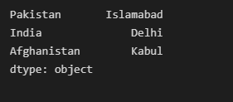

**Creating Data Frame and Using head()**

**Setting Index & Accessing Elements**

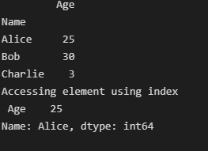

**Reindexing b row with Forward Fill**

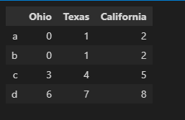

**Dropping the rows**

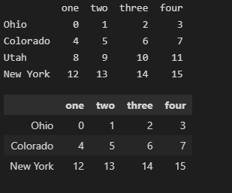

**Dropping the Columns**

**Selecting Data with loc and iloc**

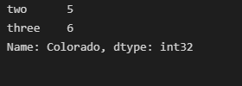

**Data Frame Arithmetic**

